git config –global user.email [“tejascs111@gmail.com”](mailto:\“tejascs111@gmail.com\”)

git config –global user.name “tejascs”

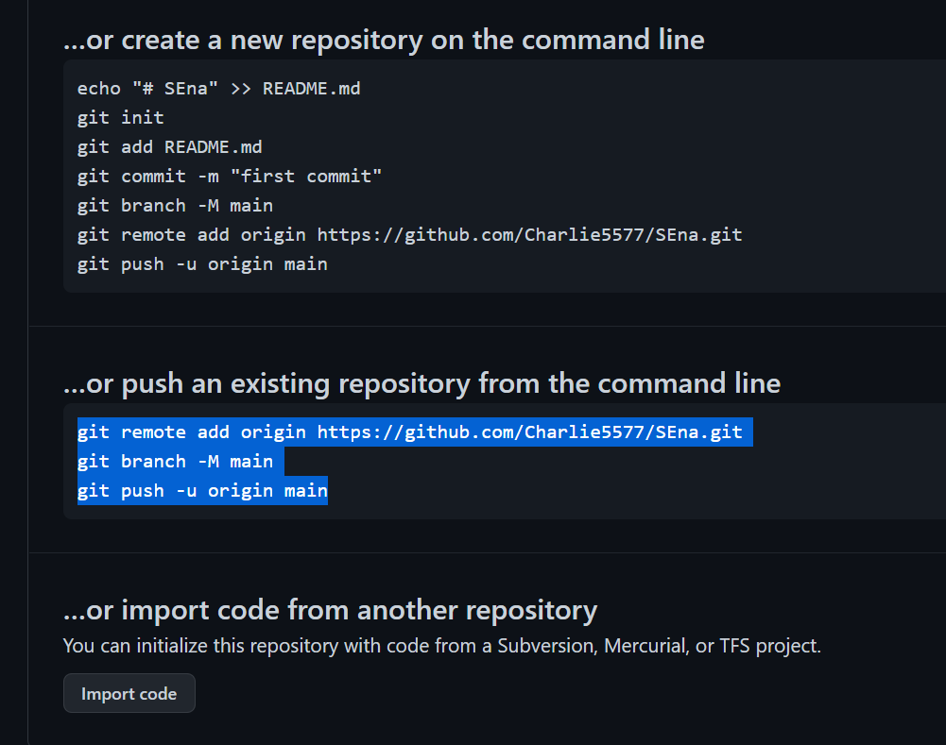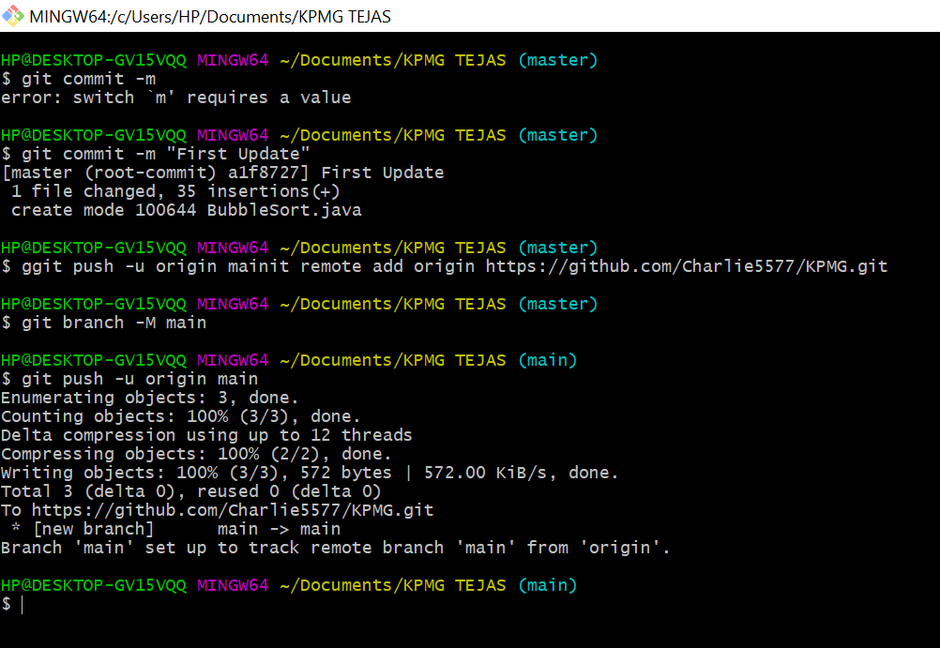

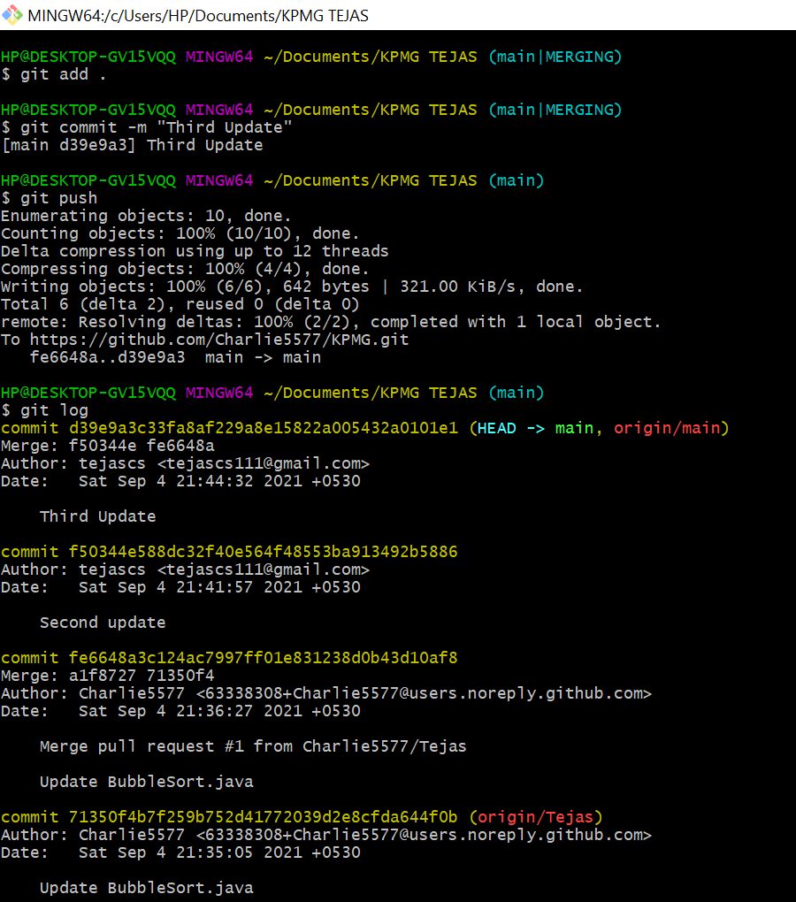

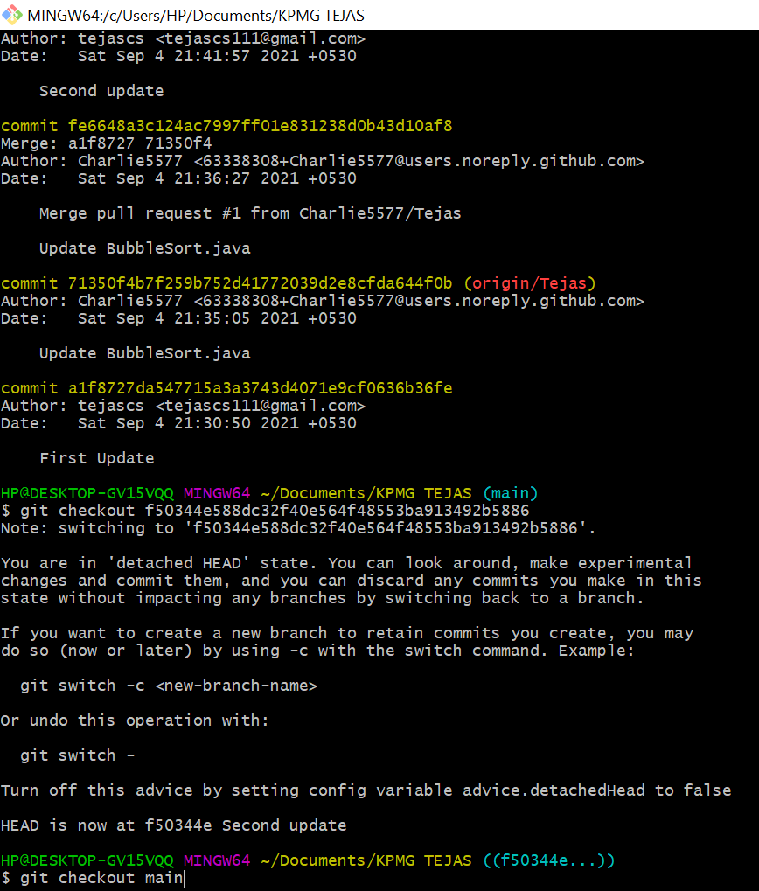<https://www.edureka.co/blog/git-commands-with-example/>